Hallo Naveen,
We want you to work further with the albertheijn site, its in the repo https://bitbucket.org/jhmarotura/ah-groenlo/src/master/
De basics are there already, the client want to use the pagemanager to create new pages, this is already in use but the data isn’t showing on the page yet, in the exta zip file ii will send you more information and images.
- On the homepage see zipfile ah homepage.pdf. u can see how the client wants it to be, the banner should be changeable through nova backend page manager.
- The boxes on the home page with voordelig koelwagen is a static block that will be always the same the bestellen butten wil send you to a form that still has to be created. The Vraag over een product block will be editable through nova. The image can be another image, the green color can be changed to all colors, the tekst must be editable and the whatsapp logo has to be editable.
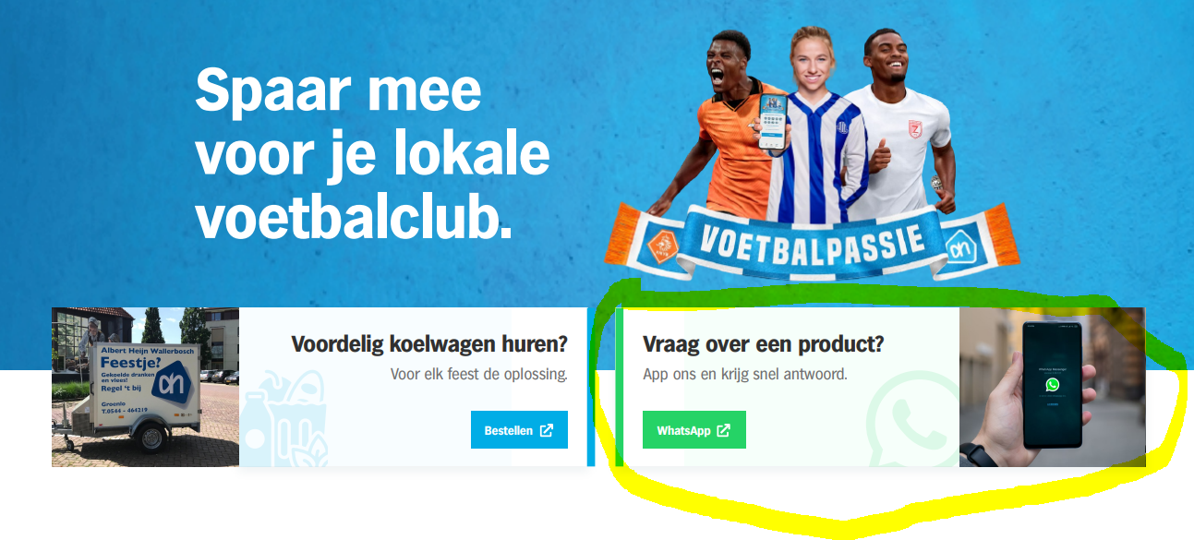
- the news article on the homepage the basics are there already, we want you to make the connection, the client wants here the newest articles, we want you to make the connection of the frontend and nova. When you select an article it will send you towards the article page.
The client only want 4 articles to be shown there is an overview button that will send you to all articles 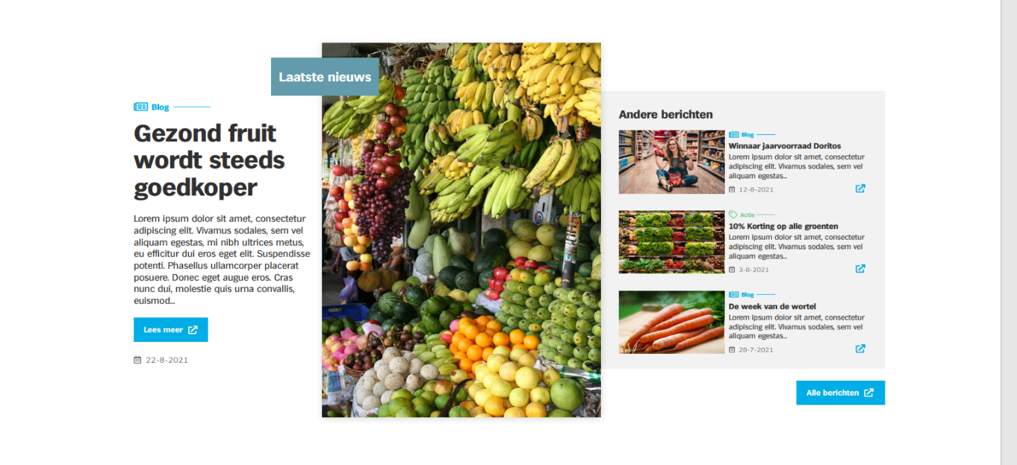
- For the near-by-news, here you can use the article module but make an exception on it because this are 3 articles that are selected by the client to be shown on the homepage, the first article must be a little bit bigger than the others.
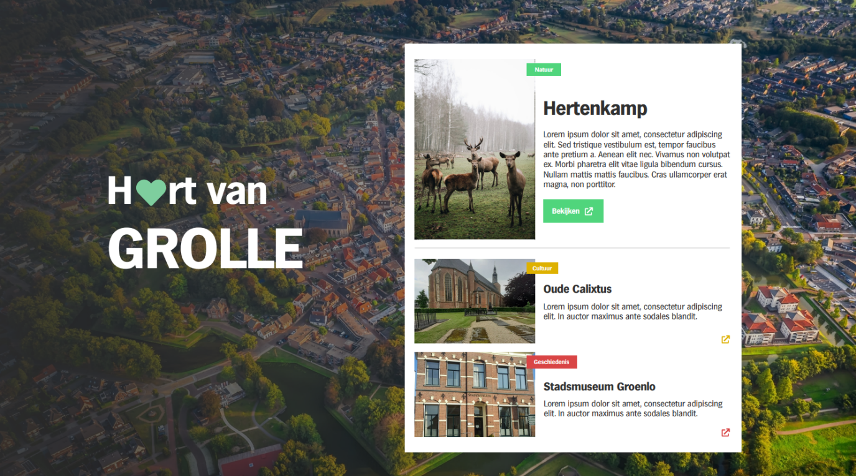
- The client wants to create its own menu by the pages that are there you van use this package for it https://github.com/optimistdigital/nova-menu-builder
- The client wants a Instagram feed on the home page there is a package for this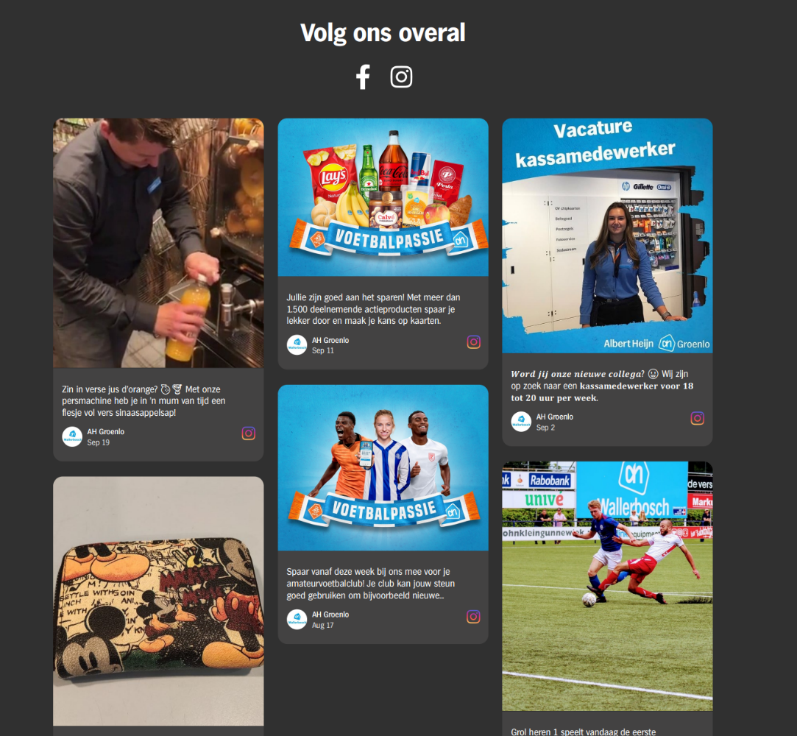

- As for the whatsapp block this will be a custom block the text and images can be replaced, even the button can get another linkto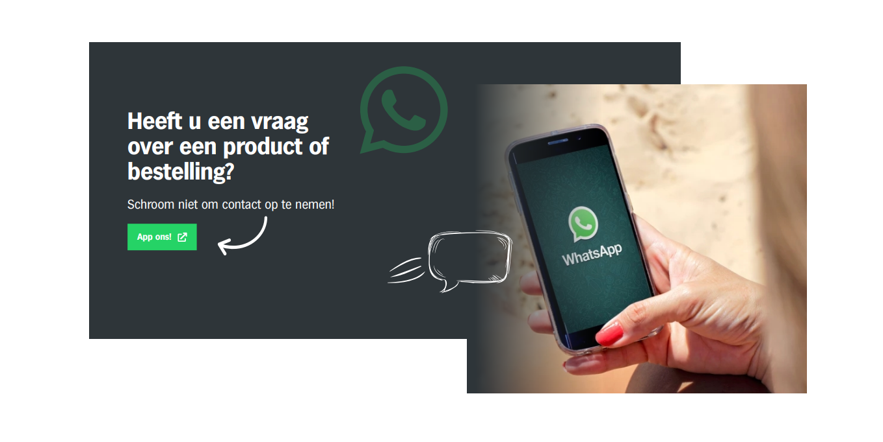

- The 3 cards on the bottom can be editable to everything, this are 3 cards with something that the client wants to highlite, the icon the text can be changed, the icons are font-awesom 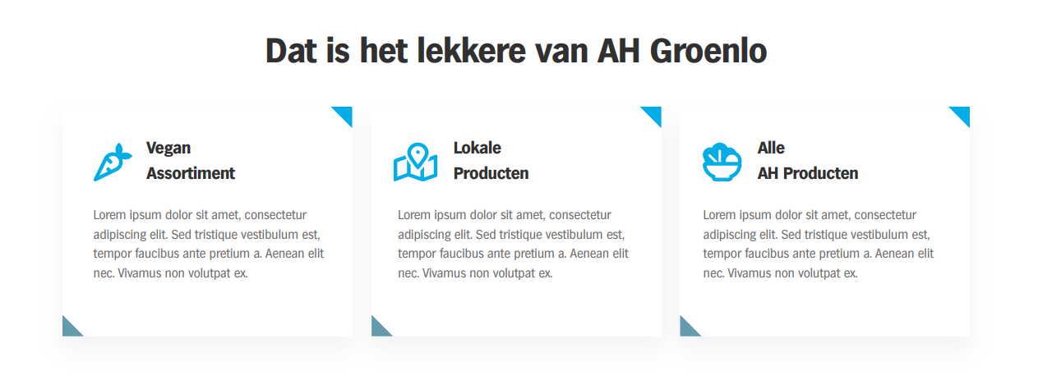

1.Client want to create new pages using pagemanager in nova backend and more info and images are in extra zip file.
2.How client want homepage should be look like in homepage.pdf.
3.And the benner should be editable in nova backend pagemanager.

4.The boxes on the homepage "voordelig koelwagen" is static block and the Bastellen button will send you to the
form that still as be created.

5."Vraag over een product" block will be editable from nova backend.
(Image, Text, Color and whatsapp image also be editable form nova backend).

6. We want to create connection between forntend and nova,
Clients wants new created article here(--)
It should be link to frontend
when select an article it should redirect to that particular article page.
7. Only show 4 latest article here.
If click overview button it will redirect to show all the article here.

1) Laatste nieuws is the first article out of 4 article ? Side of 3 is other article?
Date should be the created date of article ?

8. For Near-By-News , here you can use the article module
but these 3 article (--) should be selected by client in backend that will show on homepage.
First article little bit bigger than others.

This also have article show in home page ?

9. Clients want to create own menu with the link of page.

10. The client wants a Instagram feed on the home page.

11. For whatsapp block -> Text, Images are editable, Button can get link. (Call Back to action)
12. 3 cards on the bottom, all are editable, icons are font-awesom.

13. Mobile responsive for homepage, article or article detail page , Overview page.

In Article page how should look like ? (I mean design)
In Overview page how should look like? (I mean design)

Footer: Direct naar (Directly to) link
Header Menu : same

Nieuws & Acties (News & Promotions)
Lokaal betrokken (Locally involved)
Werken bij (Work at)
Over AH Groenlo (About AH Groenlo)

1) This link to point same page now
2) This should be static menu ?
3) Clients created own menu where should be placed? (after the exisiting menu or replace the existin menu) ?

Koelwagen huren button( Rent a refrigerated van)
Footer menu :
Algemene voorwaarden (Terms and Conditions)
Privacy statement (Privacy statement)
Cookiebeleid (Cookie Policy)

footer social icon in document present.

This is multilanguage or not ?

